Lab 2

Objective :To create database from ER diagram

1. Create database for the following case studies:
   1. The study team identified a preliminary set of 11 entity types that describe the data required by the hospital in support of the various business functions: FACILITY, PHYSICIAN, PATIENT, DIAGNOSTIC UNIT, WARD, STAFF, ORDER, SERVICE/ DRUG, MEDICAL/SURGICAL ITEM, SUPPLY ITEM, and VENDOR. From discussions with hospital staff, reviewing hospital documents, and studying existing information systems, the study team developed a list of business rules describing the policies of the hospital and nature of the hospital’s operation that govern the relationships among these entities. Some of these rules follow:
2. A FACILITY maintains one or more DIAGNOSTIC UNITs (radiology, clinical laboratory, cardiac diagnostic unit, etc.).
3. A FACILITY contains a number of WARDs (obstetrics, oncology, geriatrics, etc.).
4. Each WARD is assigned a certain number of STAFF members (nurses, secretaries, etc.); a STAFF member may be assigned to multiple WARDs.
5. A FACILITY staffs its medical team with a number of PHYSICIANs. A PHYSICIAN may be on the staff of more than one FACILITY.
6. A PHYSICIAN treats PATIENTs, and a PATIENT is treated by any number of PHYSICIANs.
7. A PHYSICIAN diagnoses PATIENTs, and a PATIENT is diagnosed by any number of PHYSICIANs.
8. A PATIENT may be assigned to a WARD (outpatients are not assigned to a WARD). The hospital cares only about the current WARD a patient is assigned to (if assigned at all).
9. A PATIENT uses MEDICAL/SURGICAL ITEMs, which are supplied by VENDORs. A VENDOR also provides SUPPLY ITEMs that are used for housekeeping and maintenance purposes.
10. A PHYSICIAN writes one or more ORDERs for a PATIENT. Each ORDER is for a given PATIENT, and a PATIENT may have many ORDERs.
11. An ORDER can be for a SERVICE such as diagnostic test (lab tests such as lipid profile, CBC, liver function tests; diagnostic imaging such as MRIs and X-rays) or a DRUG.

Diagnostic Unit

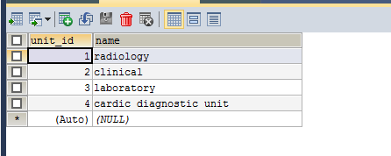

Facility

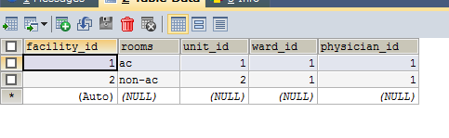

Order

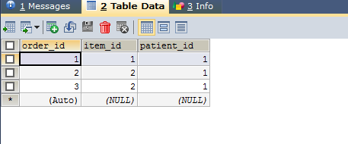

Patient

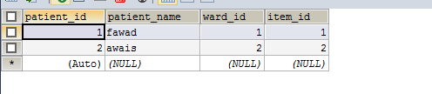

Physician

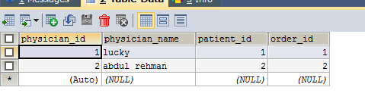

Service

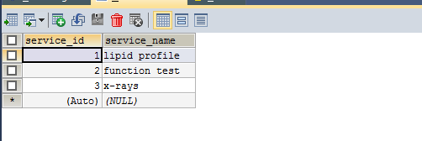

Staff

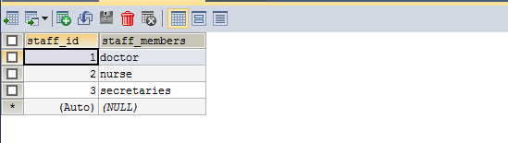

Supply item

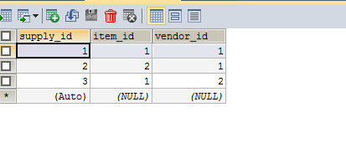

Surgical item

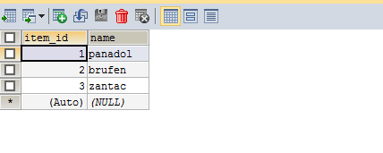

Vendor

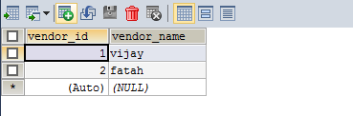

Ward

